Bangladesh University of Engineering and Technology

Course No: CSE 308

Course Name: Software Engineering Sessional

Project Name:

**Hospital Management System**

System Architecture with class and collaboration diagram.

Submitted By: Group V Date of Submission: 23.02.2014

1005011

1005016

1005019

1005021

1005024

# Subsystems

* Registration
* Patient Management
* Employee Management
* Scheduling
* Billing

# Registration System

**Use-case 1.1: Register Patient**

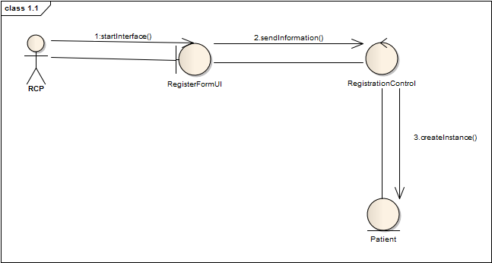

Fig: Collaboration Diagram

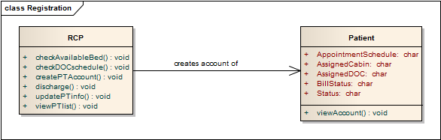

Fig: Class Diagram

**Use-case 1.2: Prepare Current Patient List**

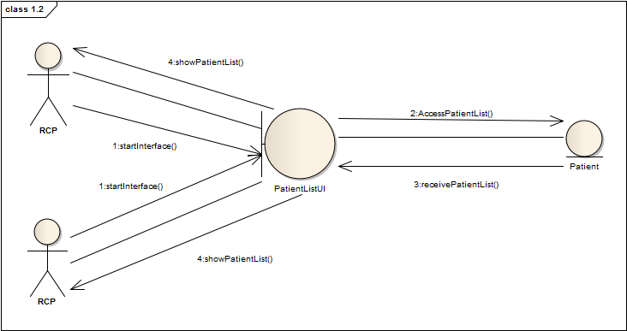

Fig: Collaboration Diagram

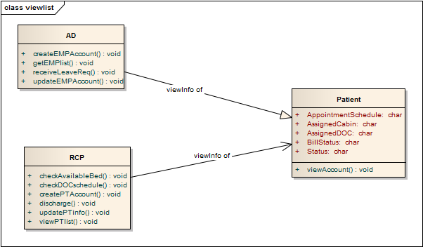

Fig: Class Diagram

# Patient Management

**Use-case 2.1: Appointment Assign**

**Use-case 2.2: Prepare Prescription**

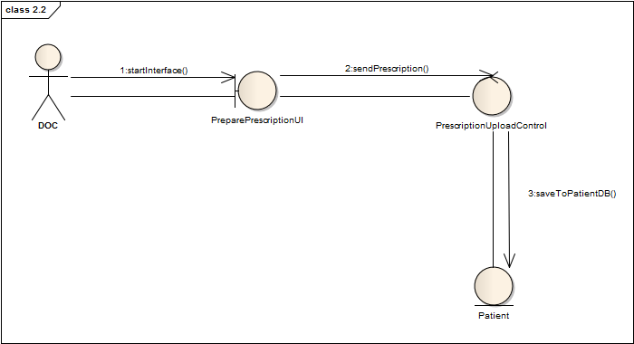

Fig: Collaboration Diagram

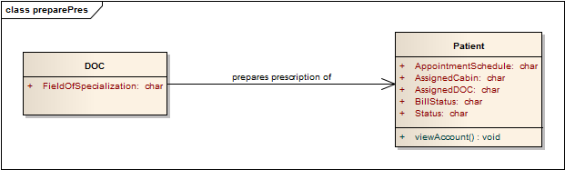

Fig: Class Diagram

**Use-case 2.3: Update Patient Database**

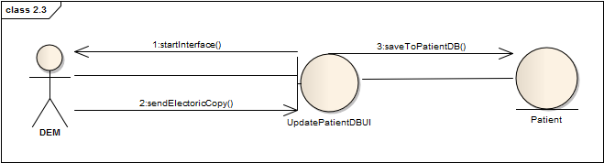

Fig: Collaboration Diagram

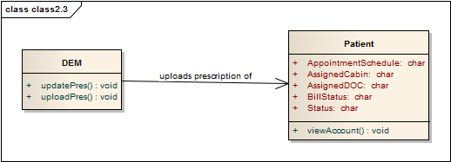

Fig: Class Diagram

**Use-case 2.4: Cabin/Bed Assign**

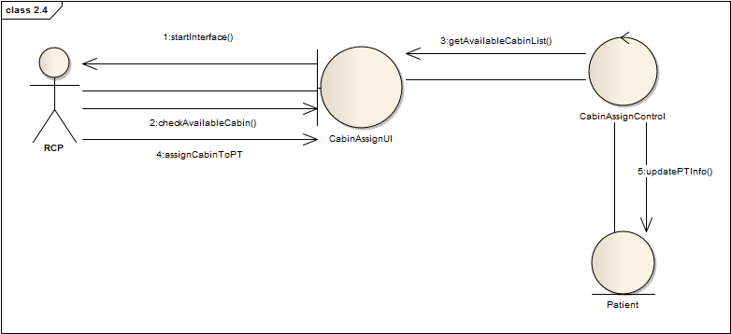

Fig: Collaboration Diagram

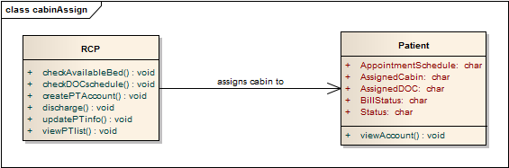

Fig: Class Diagram

**Use-case 2.5: Refer Medical Test**

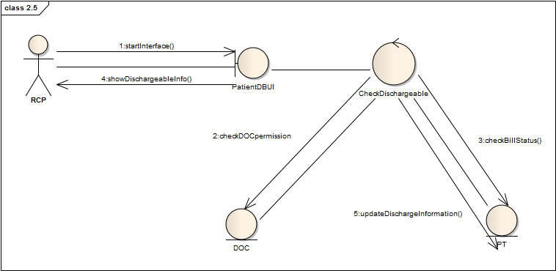

Fig: Collaboration Diagram

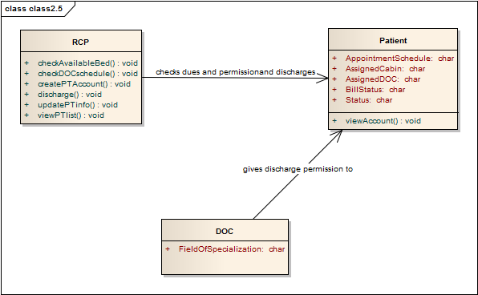

Fig: Class Diagram

**Use-case 2.6: Prepare Bill**

# Employee Management

**Use-case 3.1 : Employee Profile Creation**

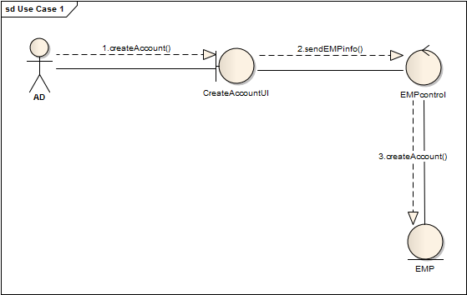

Fig: Collaboration Diagram

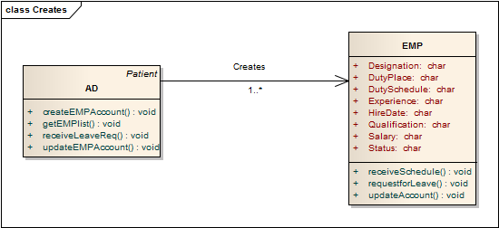

Fig: Class Diagram

**Use-case 3.2: Receive and Distribute Duty Schedule**

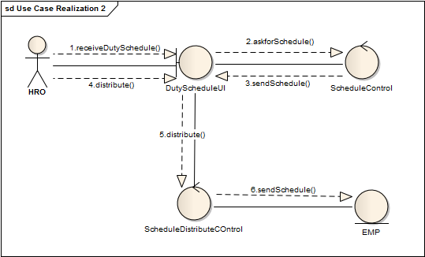

Fig: Collaboration Diagram

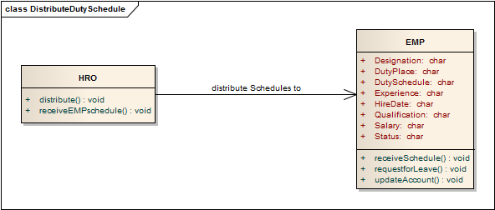

Fig: Class Diagram

**Use-case 3.3: View Employee List**

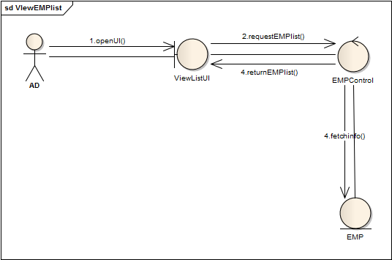

Fig: Collaboration Diagram

Fig: Class Diagram

**Use-case 3.4: Update Employee Profile**

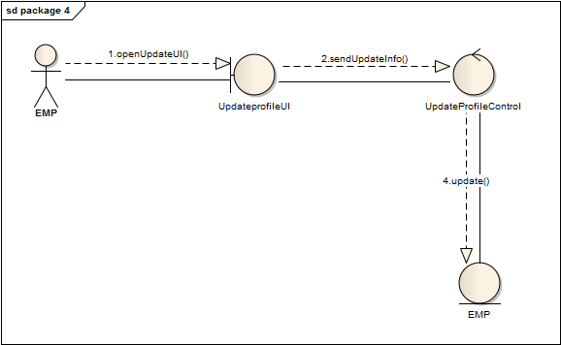

Fig: Collaboration Diagram

Fig: Class Diagram

**Use-case 3.5: Leave Management**

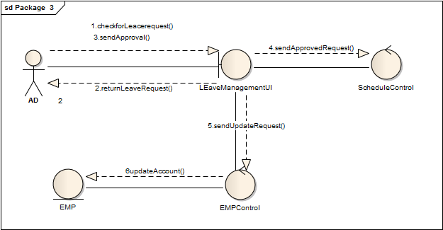

Fig: Collaboration Diagram

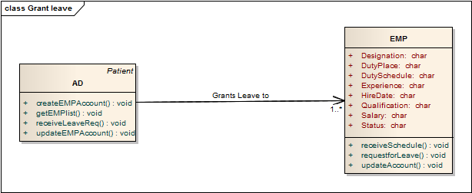

Fig: Class Diagram

# Scheduling System

**Use-case 4.1: Active Employee List**

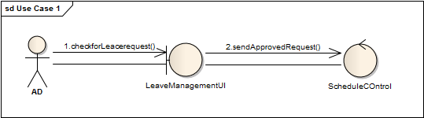

Fig: Collaboration Diagram

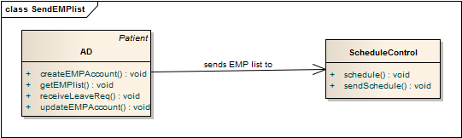

Fig: Class Diagram

**Use-case 4.2: Duty Schedule**

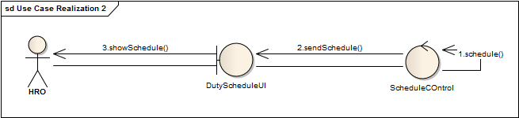

Fig: Collaboration Diagram

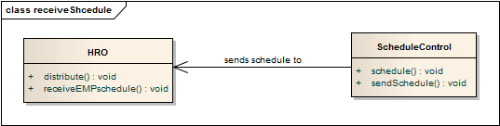

Fig: Class Diagram

# Billing System

**Use-case 5.1: Collect Bill Information**

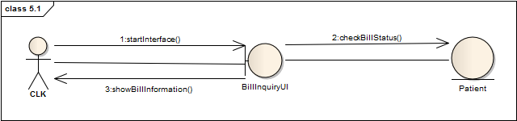

Fig: Collaboration Diagram

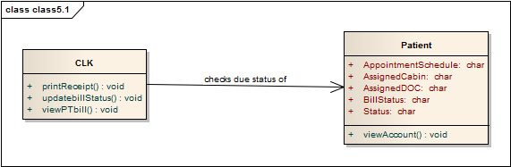

Fig: Class Diagram

**Use-case 5.2: Receive Bill**

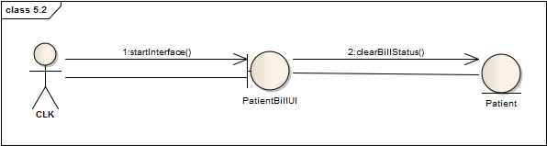

Fig: Collaboration Diagram

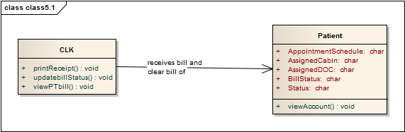

Fig: Class Diagram

**Hierarchy of Classes**

